**Information System Management Lab**

**BCOM 307**

**Assignment #10**

***Submitted by:***

**Name:** YASH JAIN

**Enrollment No:** 03914788818

**Semester:** B.Com(H) 5th Semester

**Class:** B.COM(H)

**Section:** B.Com 5A

**Date of Submission:** 01/10/2021

***Submitted to:***

**Praveen Kumar Singh**

**Assistant Professor, MAIMS**



**Department of Commerce**

**Maharaja Agrasen Institute of Management Studies**

**Affiliated to Guru Gobind Singh Indraprastha University, Delhi**

**Sector -22, Rohini, Delhi -110086, India; www.maims.ac.in**

Maharaja Agrasen Institute of Management Studies

Affiliated to GGS IP University; Recognized u/s 2(f) of UGC Recognized by Bar Council ofIndia; ISO 9001: 2015

Certified Institution Sector 22, Rohini, Delhi -110086, India; [www.maims.ac.in](http://www.maims.ac.in/)

Department of Commerce

Academic Year: 2020-21

Semester: Vth

# Assignment No.10

# Unit No:

**Course/Subject Code:** BCOM 307 **Subject Title: Information System Management Lab**

# Issue Date: Last Date of Submission:

**Instructions for Students:**

# All Questions are Compulsory.

1. The student should attach proper cover page for each assignment clearly mentioning the Assignment No.
2. Each assignment should be prepared by the student individually with proper explaination and screenshots.
3. A4 size ruled sheets should be used for the assignment.
4. Assignment pages should be serially numbered at the bottom of page.

***During online education mode, upload scanned copy of the complete assignment including cover page latest by due date.***

|  |  |  |
| --- | --- | --- |
| **Question No.** | **Question** | **CO No.** |
| 1 | Find out the names of all the clients from client_master table. | **CO1** |
| 2 | Retrieve the entire contents of client_master table. |
| 3 | Change the city of client 104 to Bangalore, of client_master table |
| 4 | Add a new column 'designation' in client_master table. |
| 5 | Delete records from client_master table where state is Haryana. |

**ASSIGNMENT 10 - ALTER COMMAND II**

**Task 1 : Find out the names of all the clients from client_master table.**

This task can be completed using the **‘select’** command.

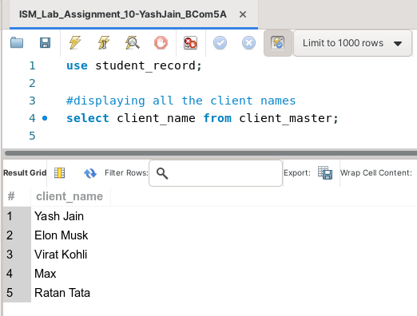

**Task 2: Retrieve the entire contents of client_master table.**

This task can be completed using the **‘select’** command.

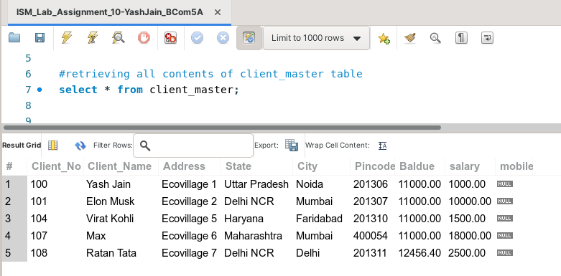

**Task 3: Change the city of client 104 to Bangalore, of client_master table**

This task can be completed using the **‘update’** command along with the **‘SET’** keyword, and the **‘where’** clause.

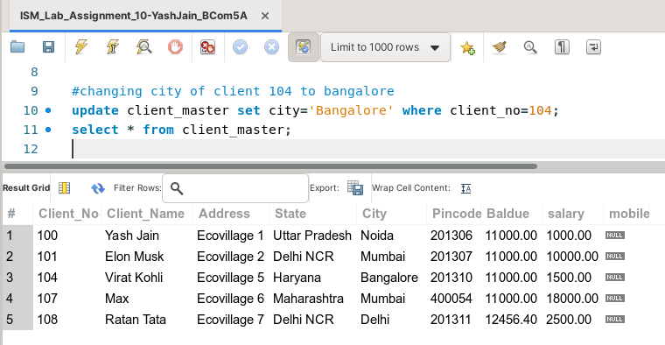

**Task 4: Add a column 'designation' in client_master table.**

The following task is completed using the **‘alter table’** command, along with the **‘add’** keyword.

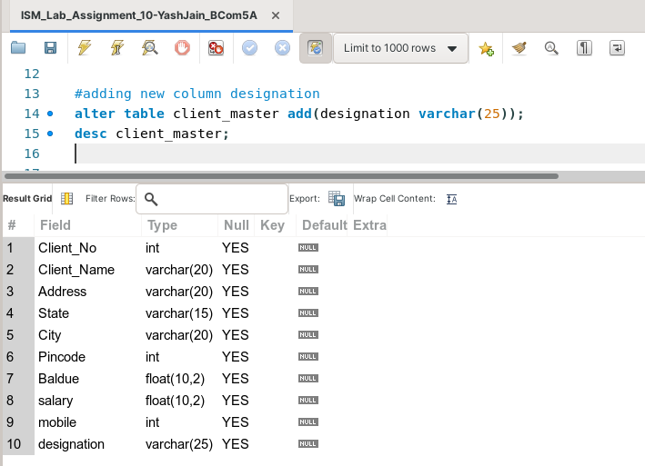

**Task 5: Delete records from client_master table where state is Haryana.**

This task can be completed using the **‘delete from’** command, with the **‘where’** clause.

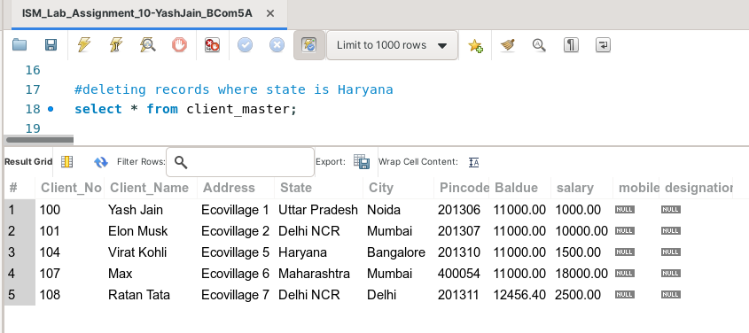

(before deletion)

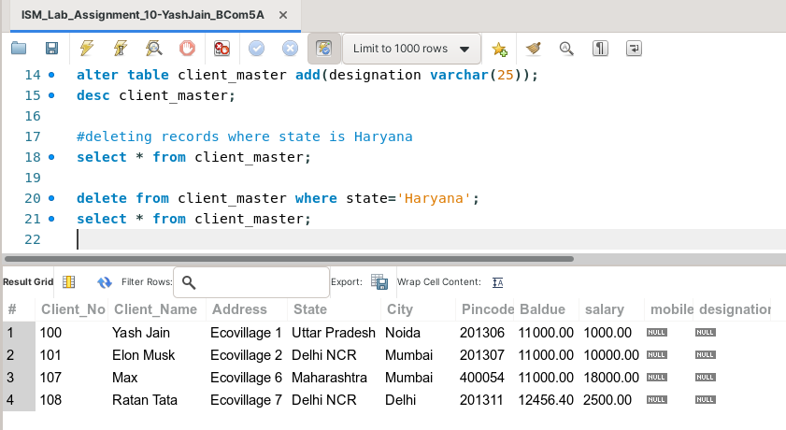

(after deletion)